## KAFKA For Begining

### Top 5 Kafka use cases

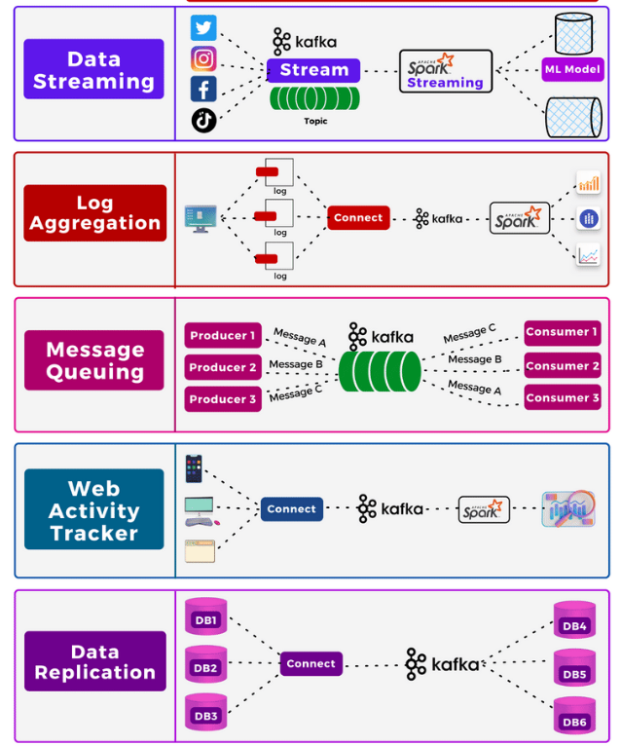

### Kafka architecture

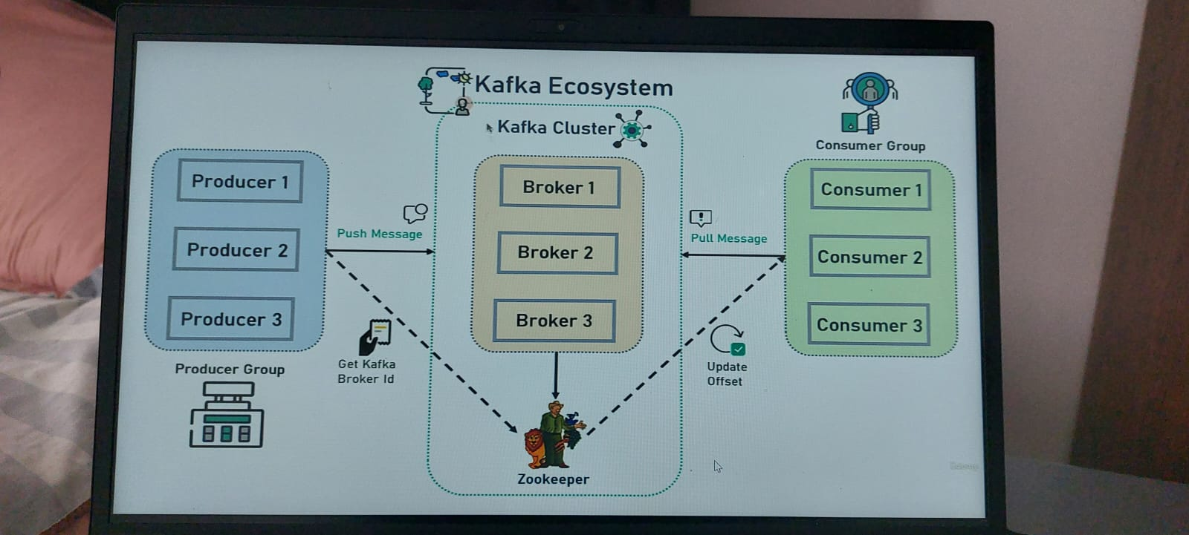

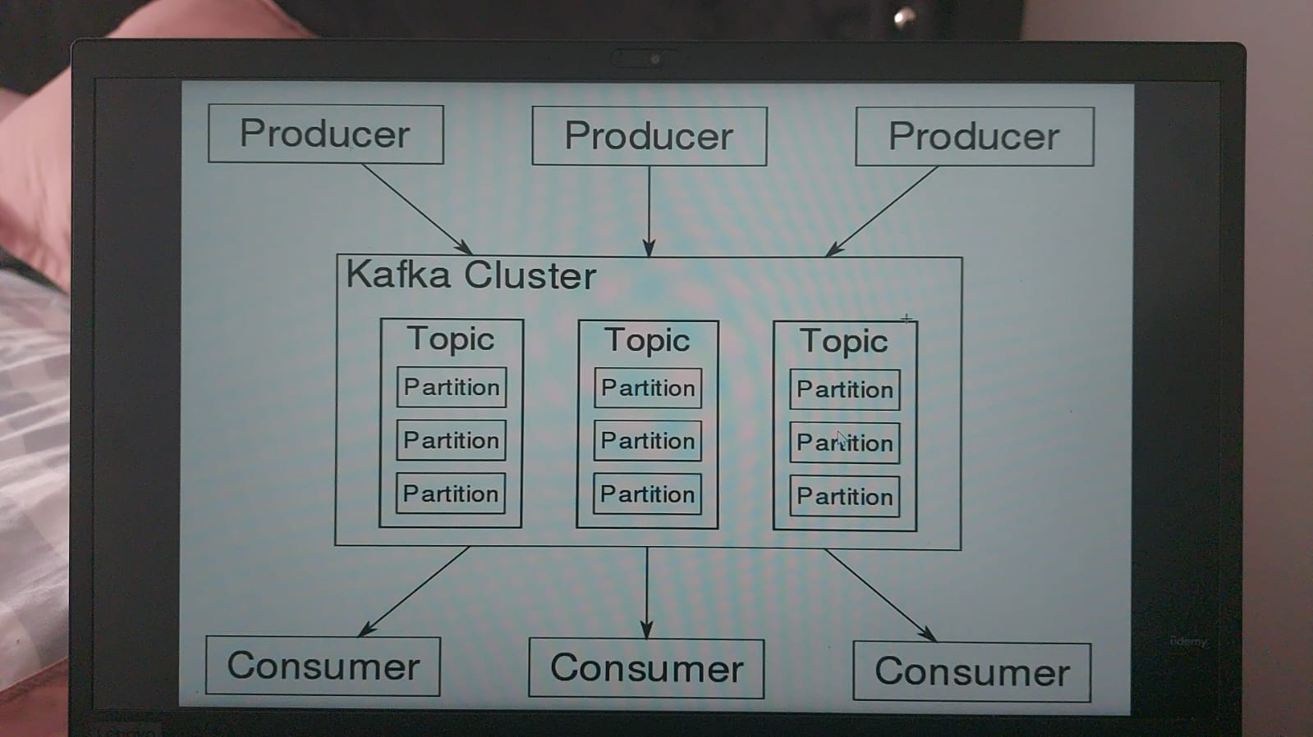

### Concepts

1. Kafka cluster: a set of brokers, minimum 3 brokers.

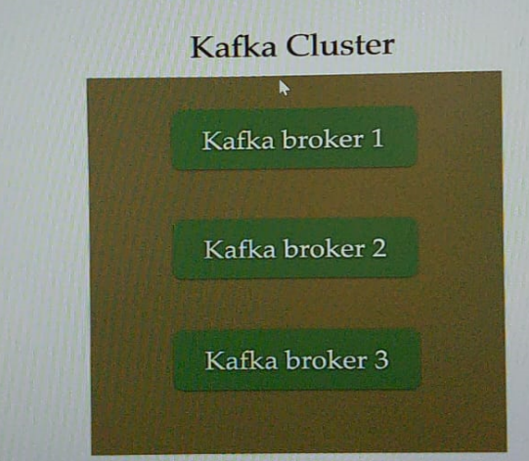

1. The Broker is the kafka server. Just the name giving to the kafka server. Producer and consumer use a broker to exchange messages.

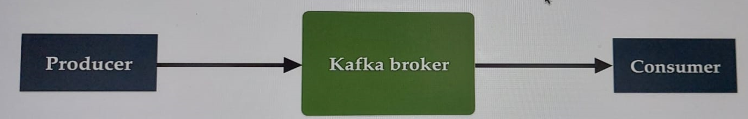

1. Producer: is an application that sends messages. Not directly to consumer but via a broker(kafka server).



1. Consumer is an application that reads message from kafka server(broker). Any application that requests data from a kafka server is a consumer.



1. Kafka Topic: is like a table in database or folder in a file system. It is identified by name. We can have any number of topics.

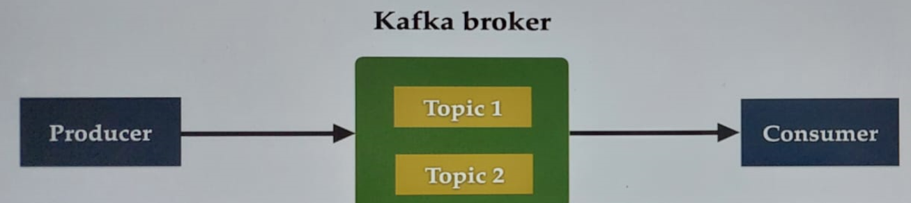

1. Kafka Partitions: Kafka topics are divided into a number of partitions which contain records (large data).

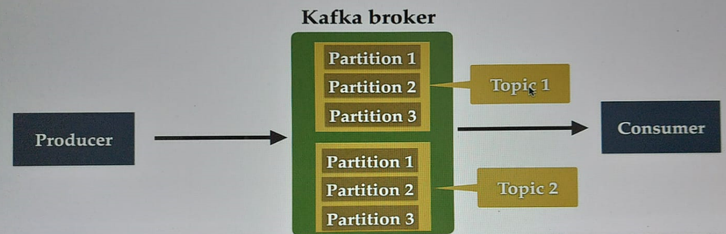

1. Offset is a sequence of ids given to messages as the arrive at a partition. Once the offset is assigned it will never be changed. The first message gets an offset zero, next message offset one, …

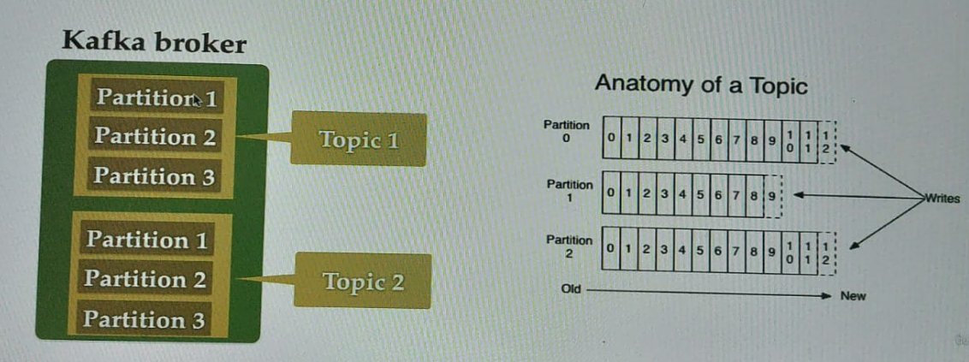

1. Consumer Groups: Contains one or more consumes working together to process the messages.

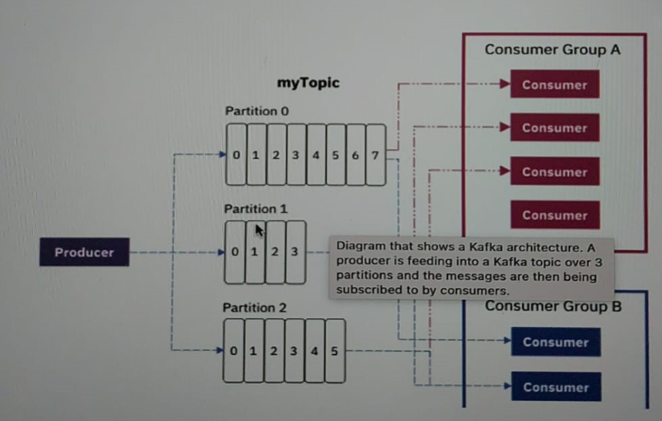

1. Zookeeper: is a service that manage all the stage of kafka cluster, kafka broker, topic.

### Install and setup

Download apache kafka here <https://kafka.apache.org/quickstart> and follow the steps. Start zookeeper-server and kafka-server.

* Command to execute zookeeper server on windows: .\bin\windows\zookeeper-server-start.bat .\config\zookeeper.properties

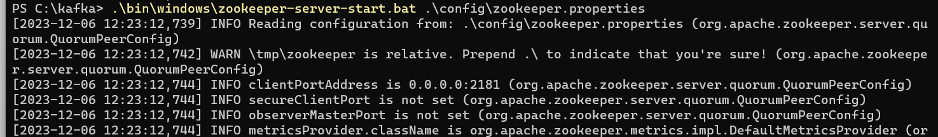

* Command to execute kafka server on windows:

.\bin\windows\kafka-server-start.bat .\config\server.properties

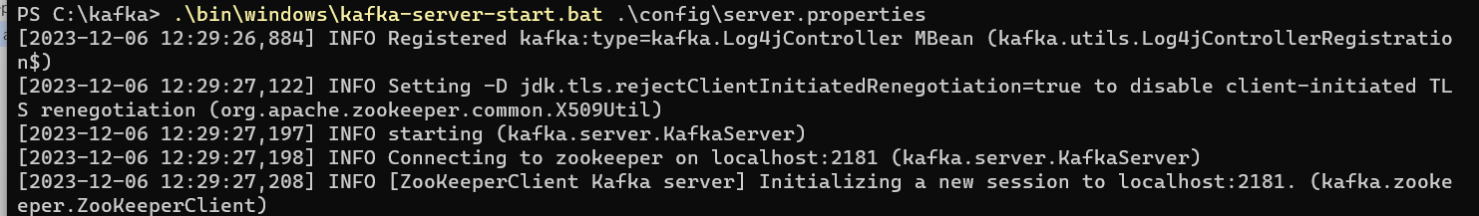

### Create and setup a spring boot project in intellij

You can use this link <https://start.spring.io/>

Make sure to add the spring-boot kafka maven/gradle dependency

<https://docs.spring.io/spring-kafka/reference/quick-tour.html>

### Configure Kafka Producer and Consumer

Configure your application.yml like this

spring:  
 kafka:  
 producer:  
 bootstrap-servers: localhost:9092  
 key-serializer: org.apache.kafka.common.serialization.StringSerializer  
 value-serializer: org.apache.kafka.common.serialization.StringSerializer  
  
 consumer:  
 bootstrap-servers: localhost:9092  
 group-id: myGroup  
 auto-offset-reset: earliest  
 key-deserializer: org.apache.kafka.common.serialization.StringDeserializer  
 value-deserializer: org.apache.kafka.common.serialization.StringDeserializer

### Create kafka topic

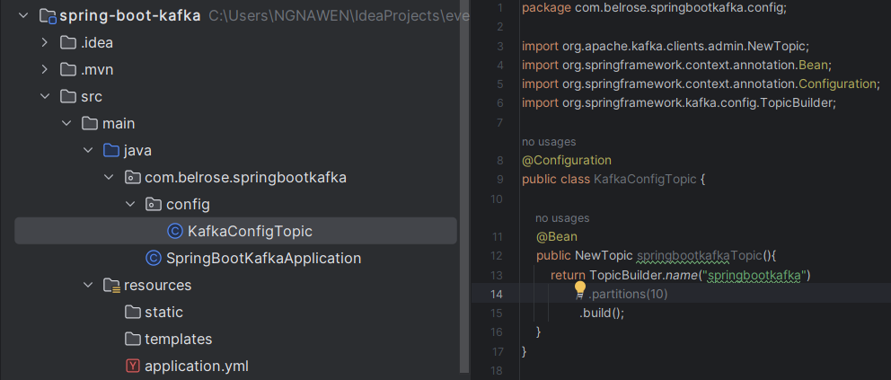

### Create kafka Producer

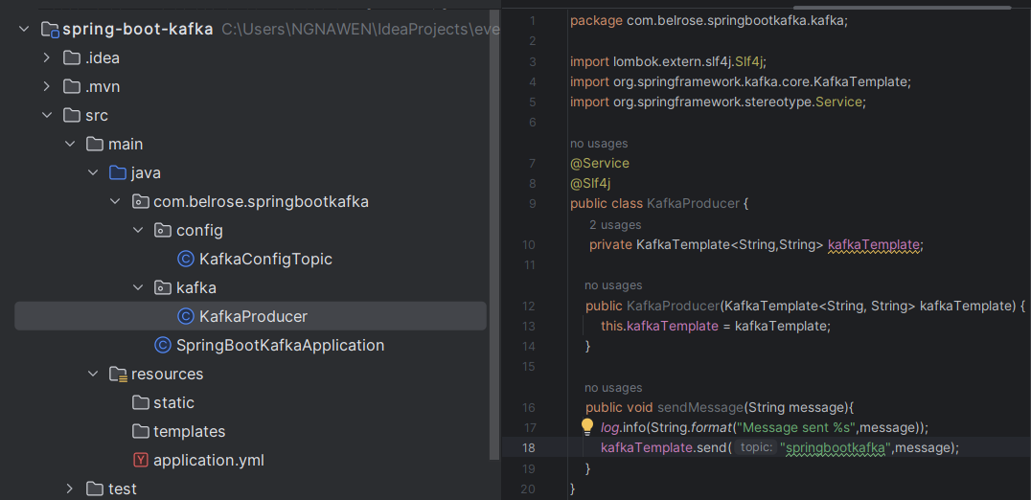

Create REST API to Send Message

Based on the Kafka architecture, The REST API will send message to producer and then the producer will send it to kafka broker.

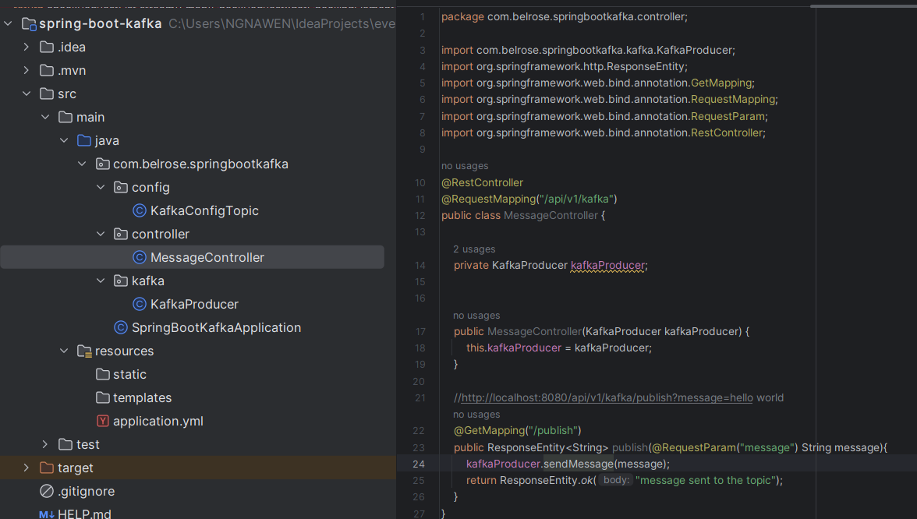

Read the events/message in the console

Execute this command in the terminal:

.\bin\windows\kafka-console-consumer.bat --topic springbootkafka --from-beginning --bootstrap-server localhost:9092

Request sent:

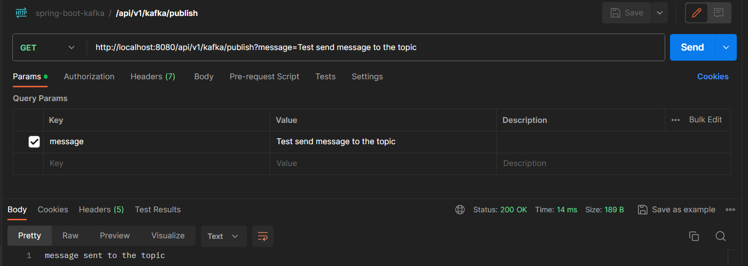

Response:



### Create kafka Consumer

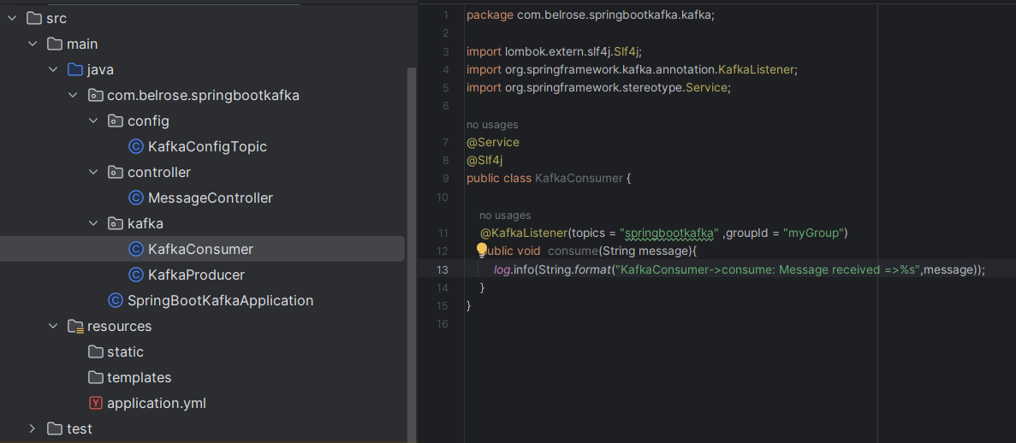

### Configure kafka Producer and Consumer for JSON Serializer and Deserializer

spring:  
 kafka:  
 producer:  
 bootstrap-servers: localhost:9092  
 key-serializer: org.apache.kafka.common.serialization.StringSerializer  
 *#value-serializer: org.apache.kafka.common.serialization.StringSerializer* value-serializer: org.springframework.kafka.support.serializer.JsonSerializer  
  
 consumer:  
 bootstrap-servers: localhost:9092  
 group-id: myGroup  
 auto-offset-reset: earliest  
 key-deserializer: org.apache.kafka.common.serialization.StringDeserializer  
 *#value-deserializer: org.apache.kafka.common.serialization.StringDeserializer* value-deserializer: org.springframework.kafka.support.serializer.JsonDeserializer  
 properties:  
 spring:  
 json:  
 trusted:  
 packages: '*'

### Create a simple POJO to Serializer and Deserializer

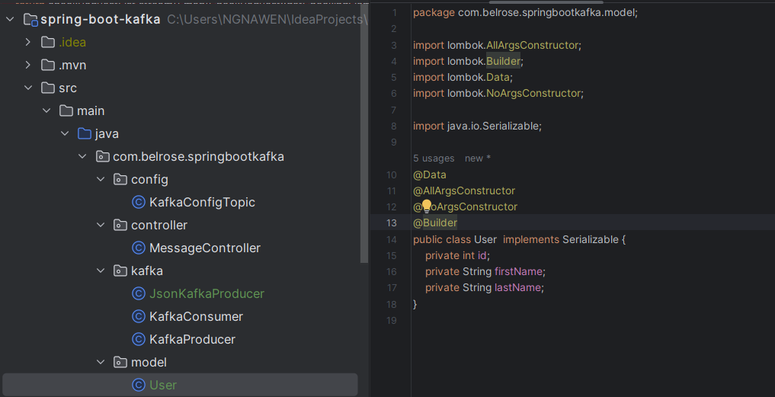

### Create kafka producer to produce JSON message

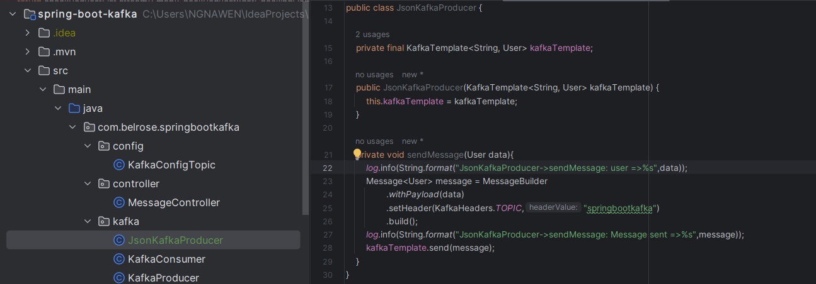

### Create REST API to send JSON Object

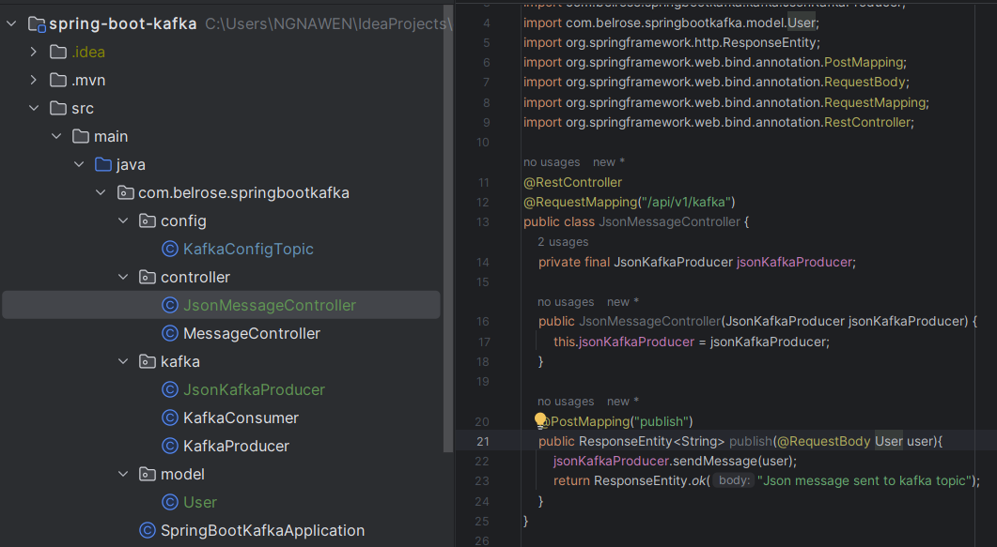

### Create kafka Consumer to consume JSON message

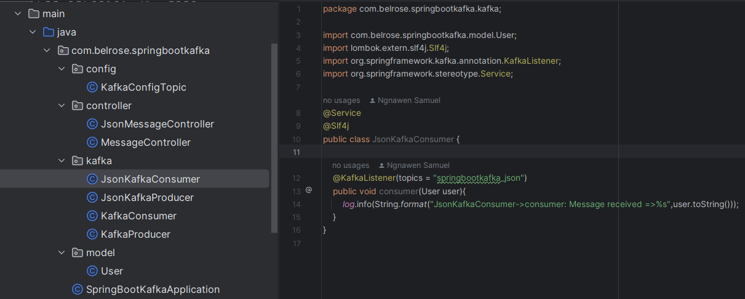

## KAFKA in the real project

### Context

To Read the real time data from Wikimedia and save it in our own database. Specifically, the Kafka producer will read the realtime data from Wikimedia and then send it to Kafka broker and the the kafka consumer will read the kafka broker and save the data in the database.

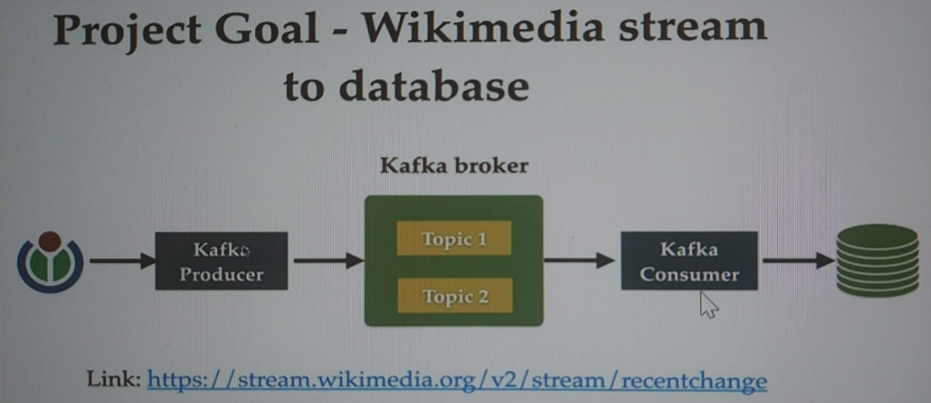

List of endpoints that you can hit: <https://stream.wikimedia.org/?doc#/streams>

Show the events stream demo: <https://esjewett.github.io/wm-eventsource-demo/>

Show the statistics of recent changes: <https://codepen.io/Krinkle/pen/BwEKgW>

### Spring boot kafka project setup (using multi module maven project)

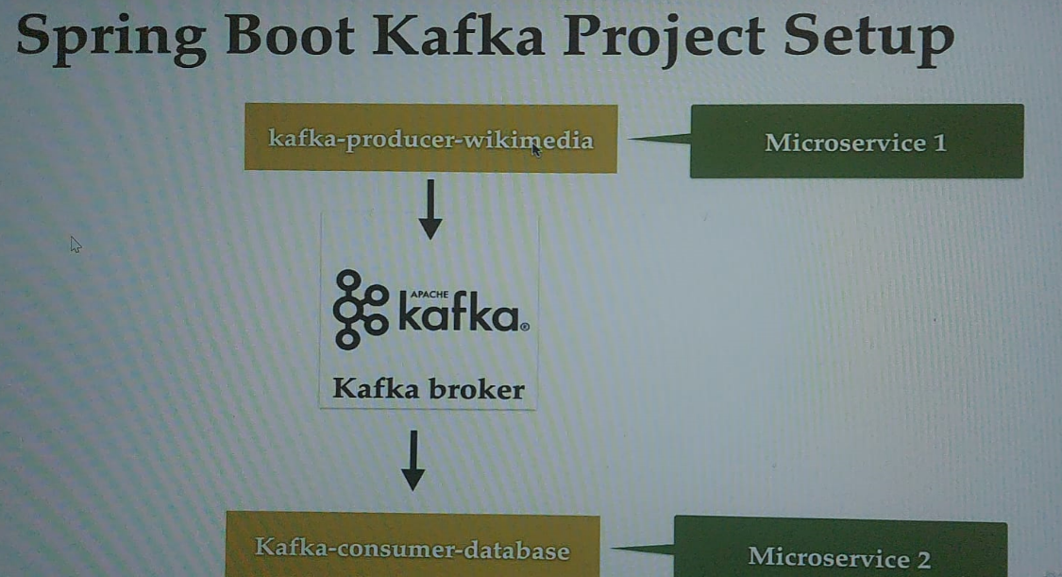

##### Create the parent spring boot project

Create a spring boot project in <https://start.spring.io/> and make it as a parent project. For that add this tag <packaging>pom</packaging> to set the project as multi modules project and add those modules.

NB: The <modules> </modules> is automatically added when the module is created within the parent project.

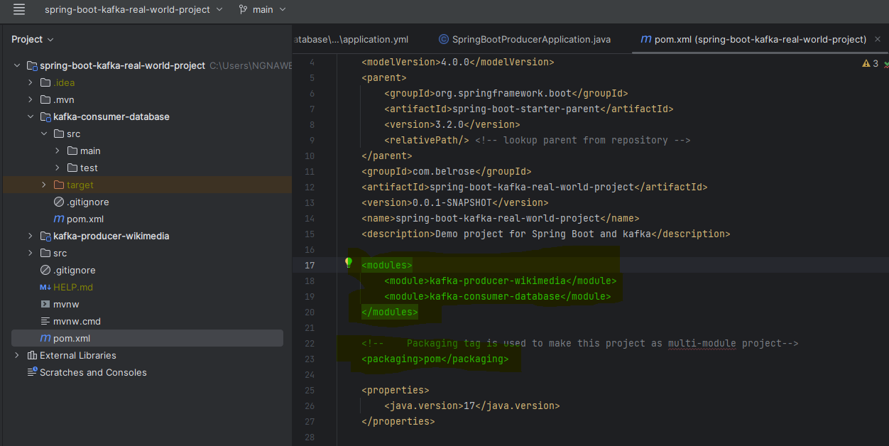

##### Create the module within the parent project

Right clic on that project and create the modules within the parent project. Add this tag <packaging>jar</packaging> within the pom.xml module project.

In our case we have two modules: *kafka-producer-wikimedia* and *kafka-consumer-database*

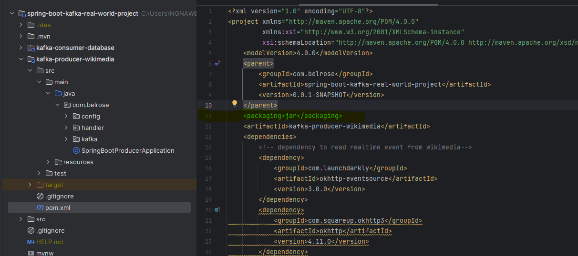

As the modules are not directly the spring boot project, we have to add a package and create the main class.

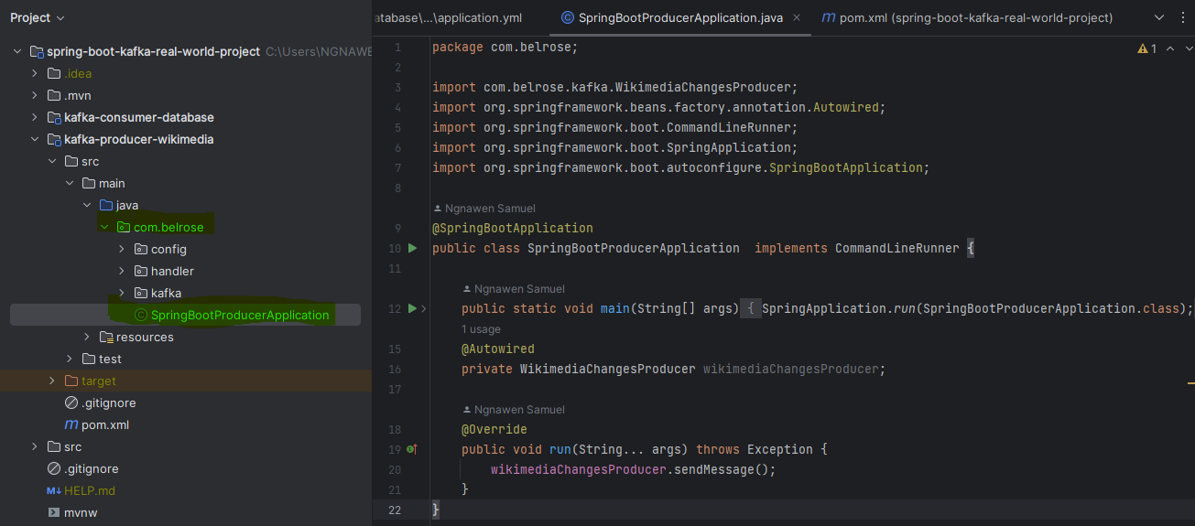

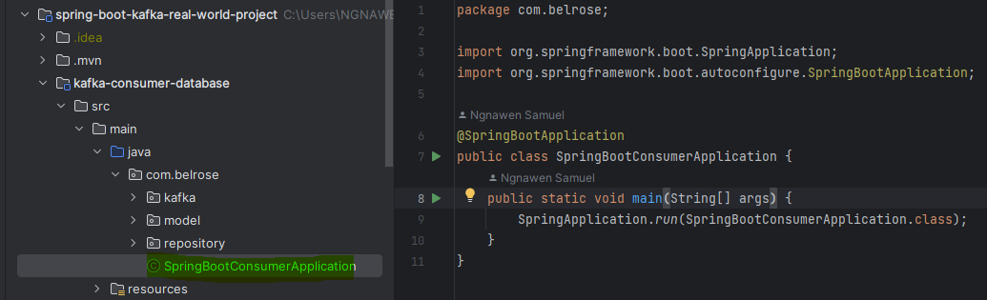

##### Test your modules

Reload the pom.xml and then clean & build the module project.

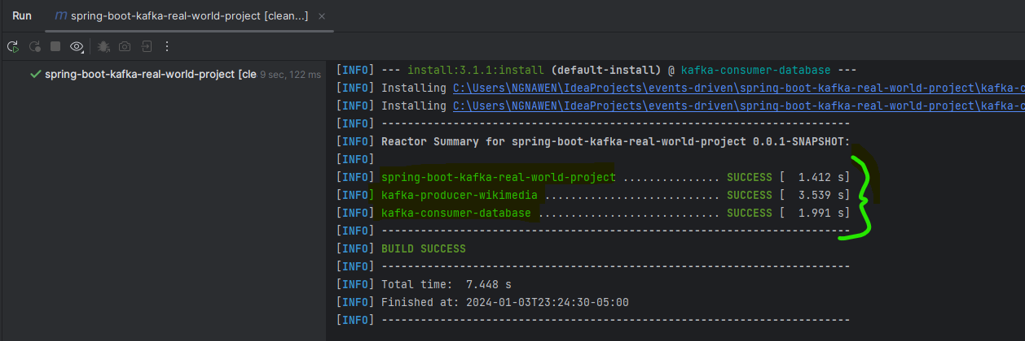

In this stage the modules are successful created and is ready.

### Create a topic

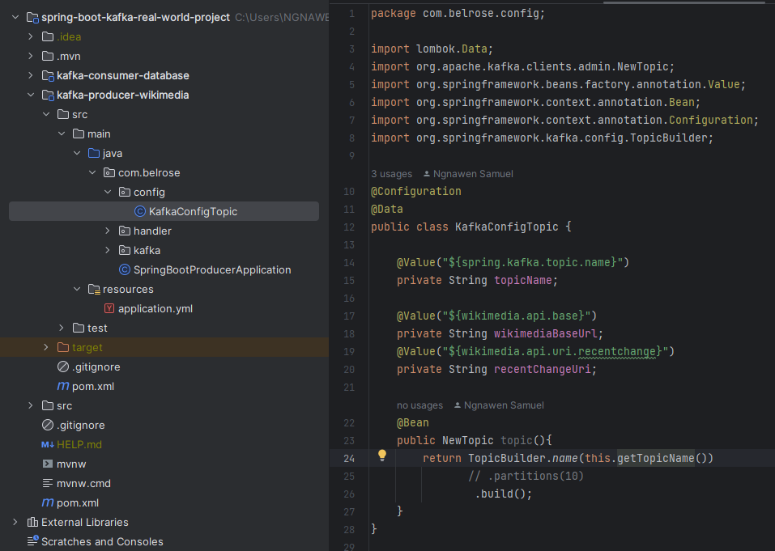

### Implemented Producer (*kafka-producer-wikimedia*)

##### Configure Wikimedia producer

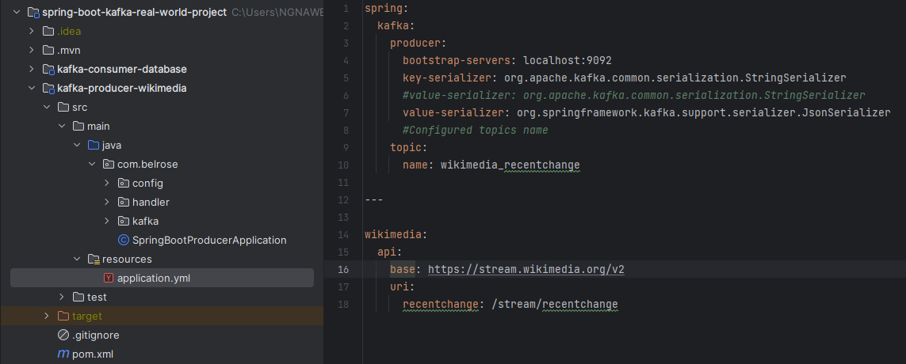

##### Adding maven dependency

To add the okhttp-eventsource dependency bolow to be able to read the data from Wikipedia. To also add jackson-core and jackson-databind dependencies

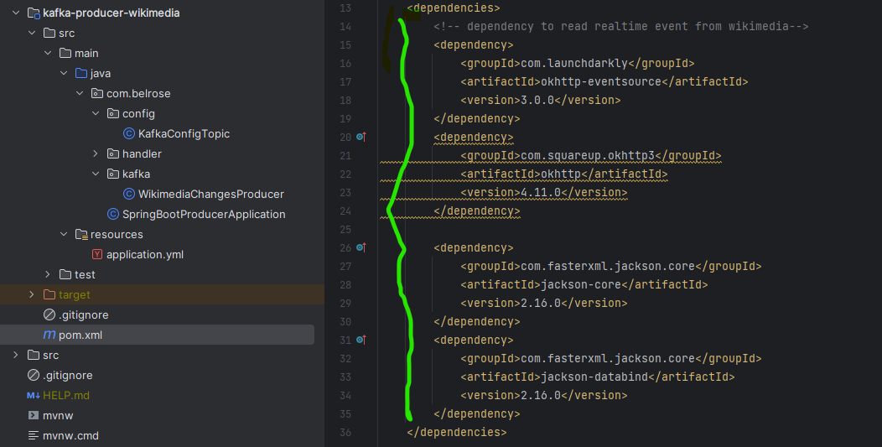

##### Create and implement the event handler

Implemented the changes handler event

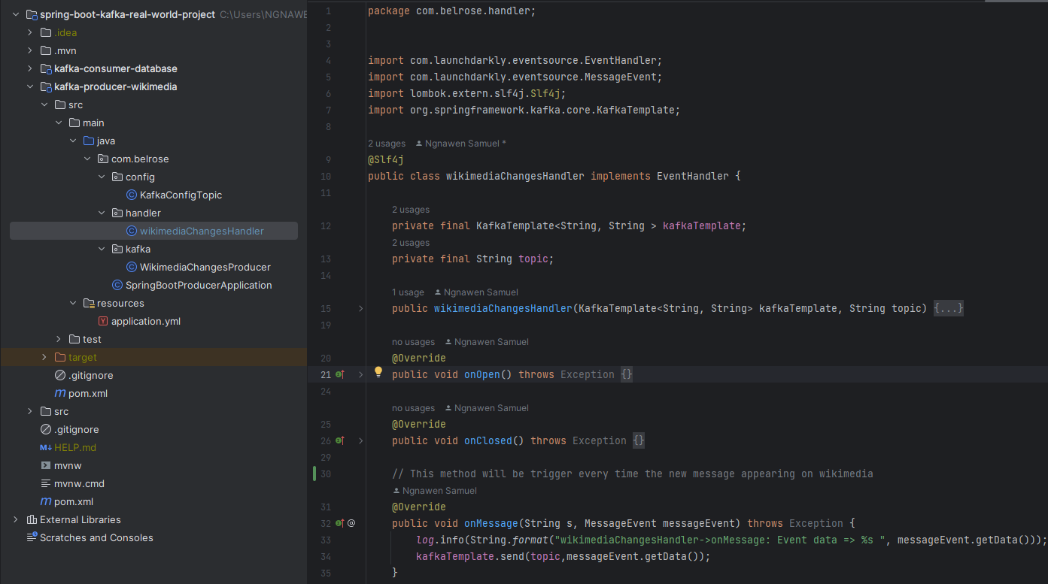

##### Create and implement the producer

To create a java class and annotated it with @Service as follow

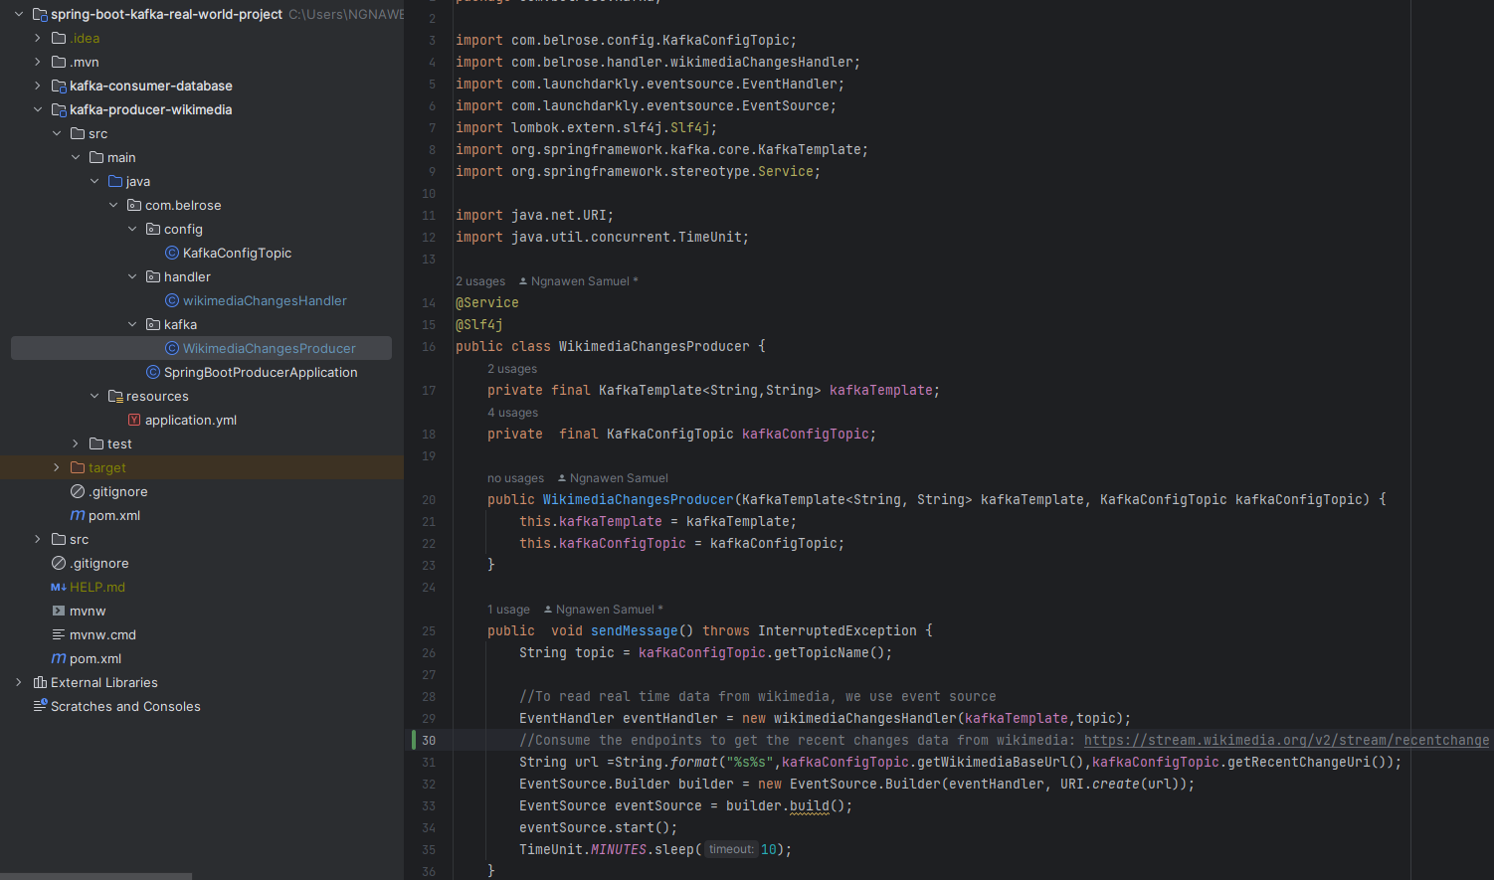

##### Run the zookeeper and kafka server

Here are the commands:

* .\bin\windows\zookeeper-server-start.bat .\config\zookeeper.properties
* .\bin\windows\kafka-server-start.bat .\config\server.properties

Or

* You can use the point 6) to start zookerper-server and kafka-server as the docker container

In case you got this issue

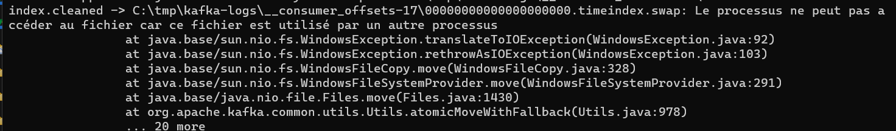

Try to delete the files in C:\tmp\kafka-logs\ and then try again. The above response means that you Kafka broker is running on port 9092

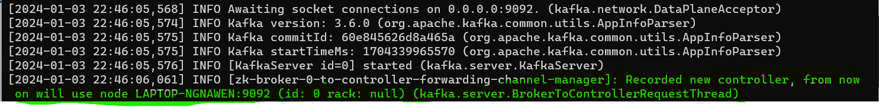

##### Run the Wikimedia producer

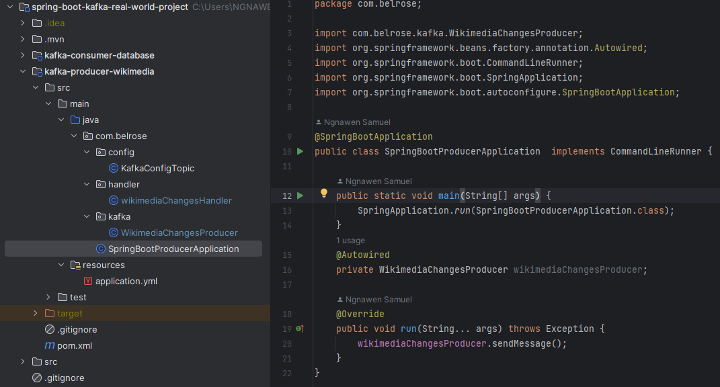

You will get this response in your terminal:

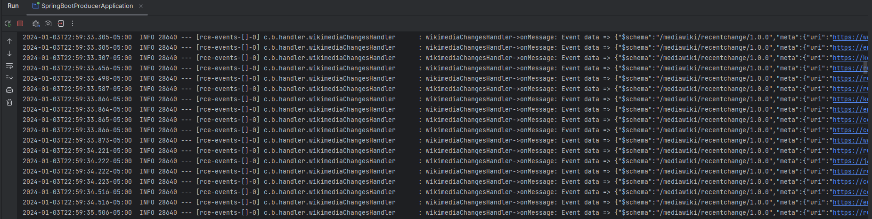

NB: Make sure your Kafka broker is running if not you will get this error message:

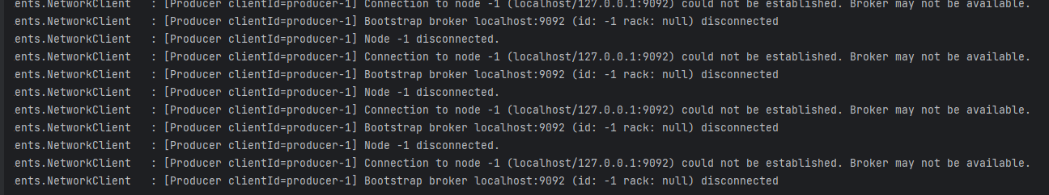

### Implement consumer (*kafka-consumer-database*)

##### Configure Wikimedia consumer and MySQL database

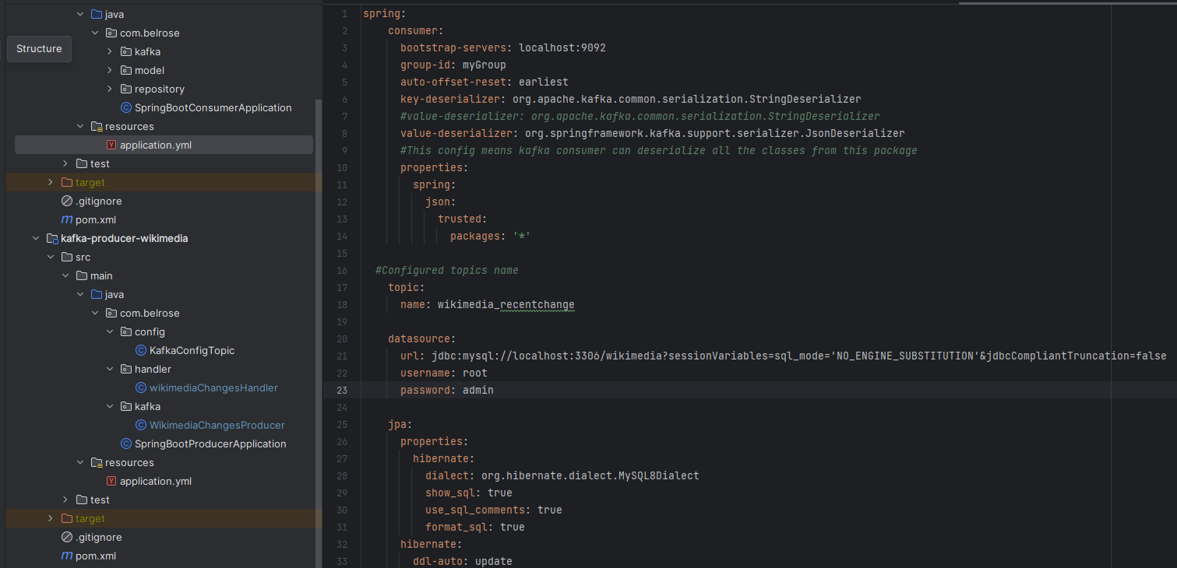

##### Create and implement your kafka consumer

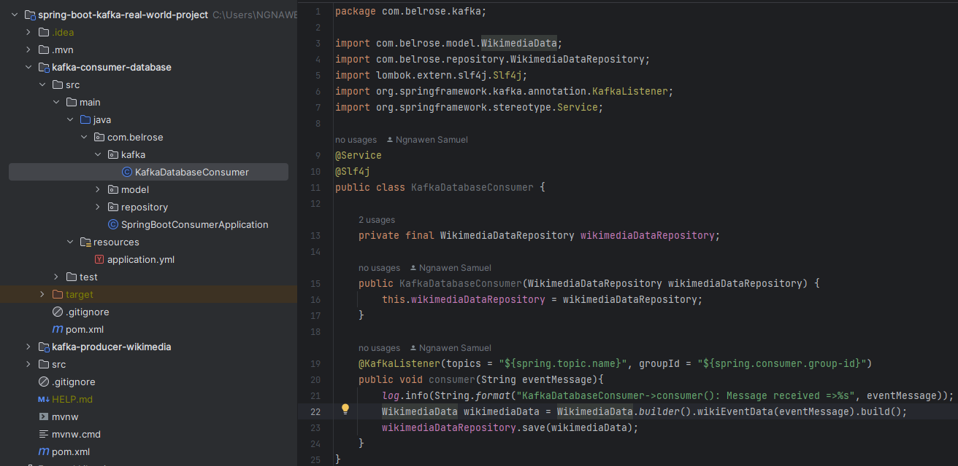

##### Save Wikimedia recent change Data into MySQL Database

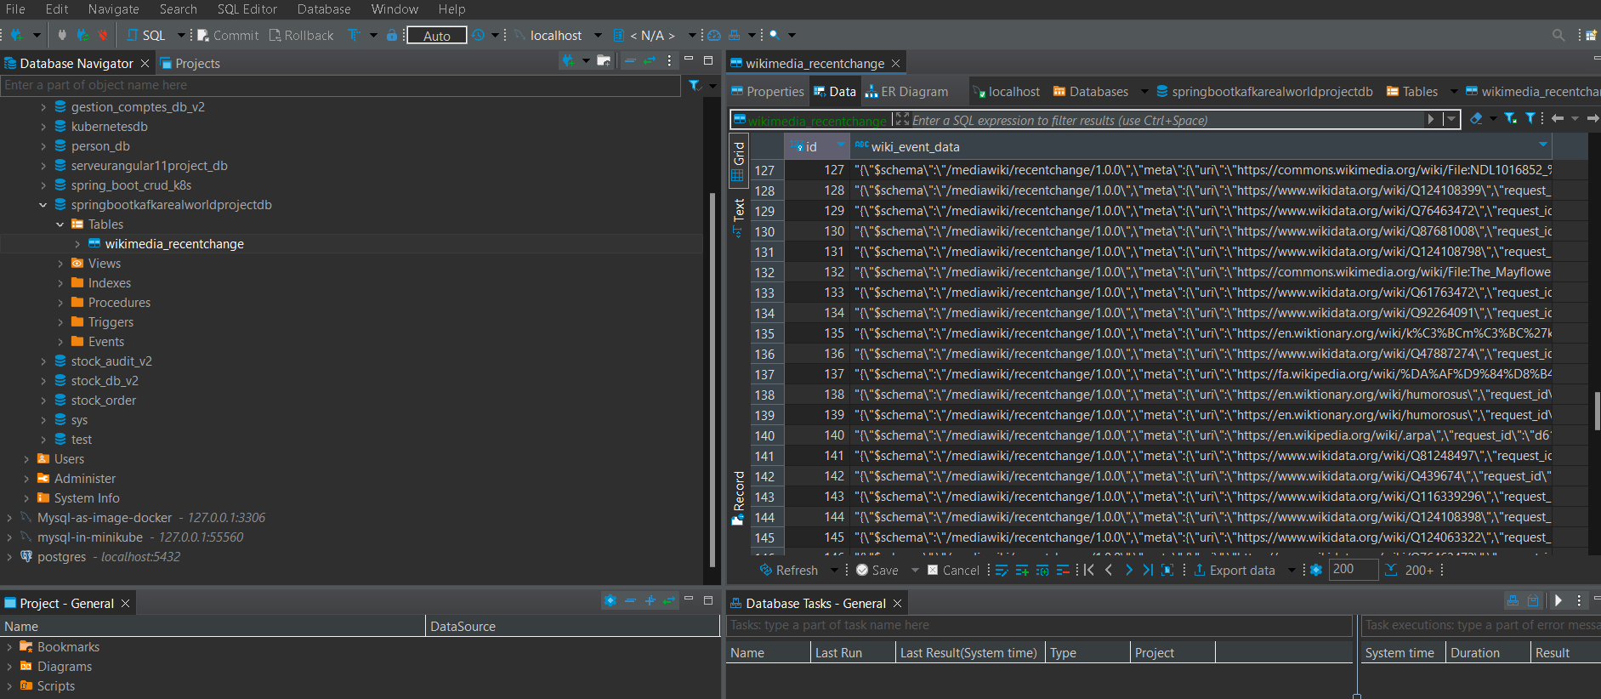

## Event-driven microservices architecture (EDMA)

It is the architecture where the applications communicate with each other by sending and/or receiving events or messages. It is a programming approach, not a language.

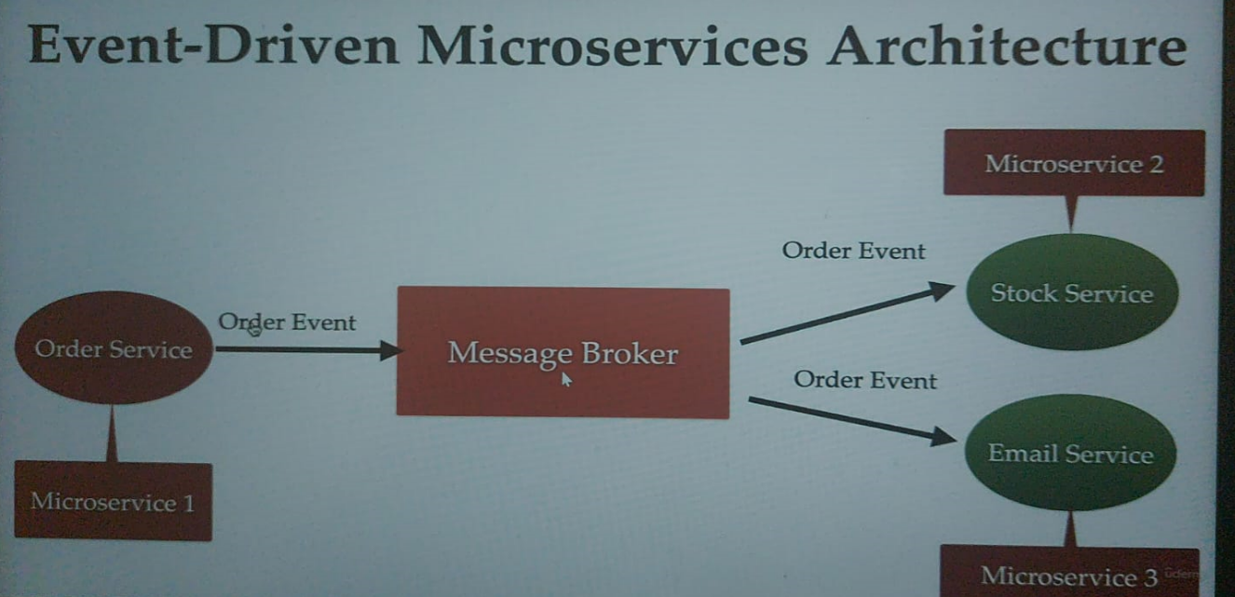

Advantages of EDMA:

* Improves flexibility and maintainability
* High scalability
* Improved availability (if one microservice go down, it won’t impacted other microservices)

## Spring boot kafka Event-Driven Microservices Architecture with Multipe Consumers

### Architecture

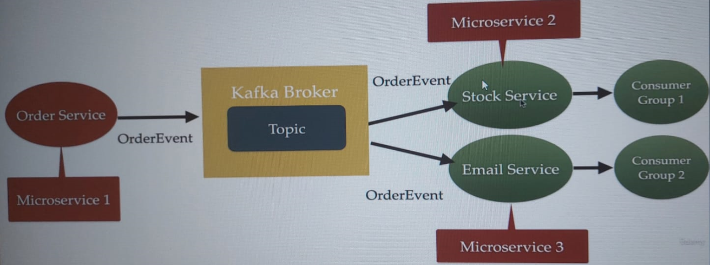

### Create mricroservices

Create 4 independents spring boot microservices:

* *orderService*
* *stockService*
* *emailService*
* *baseDomains:* will contain the DTO. It will use to transport data from consumer to producer

Create a folder (parent project) and put all those services insides this folder and then open it in the IntelliJ. After that click to load maven build on the popup.

NB: You can import another project as a module project.

### Configure those microservices

Producer(*orderService)*

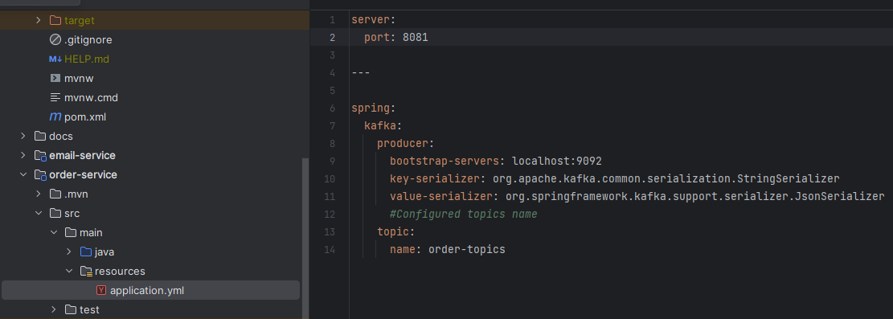

Consumers (*stockService, emailService)*

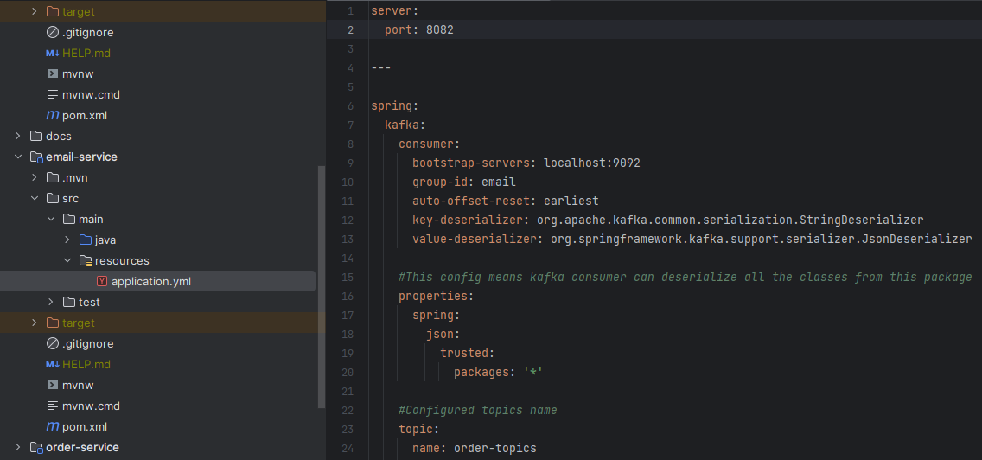

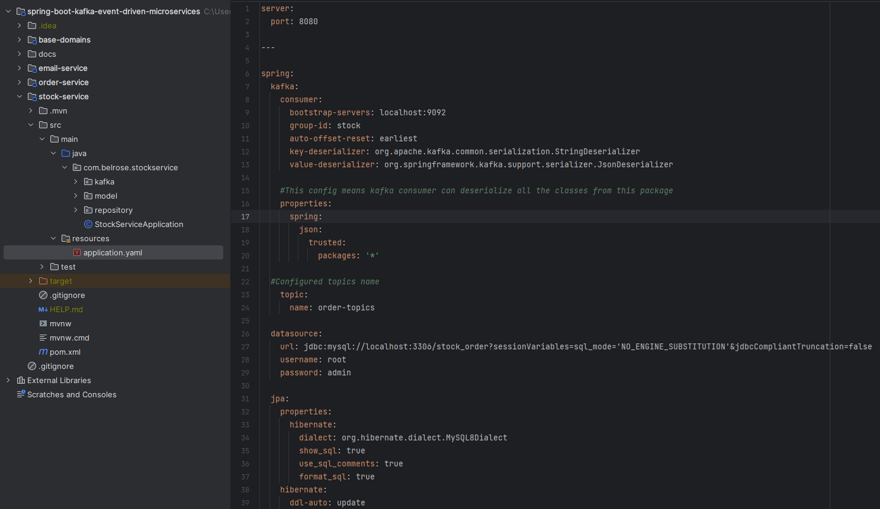

NB: When you have multiple consumers to consume the message from the single topic, you have to assign it in different Consumer group

### Implementations

##### baseDomains

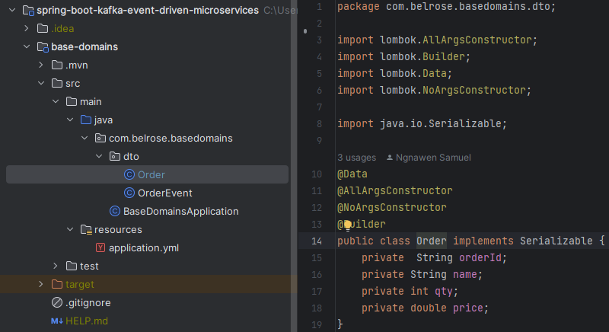

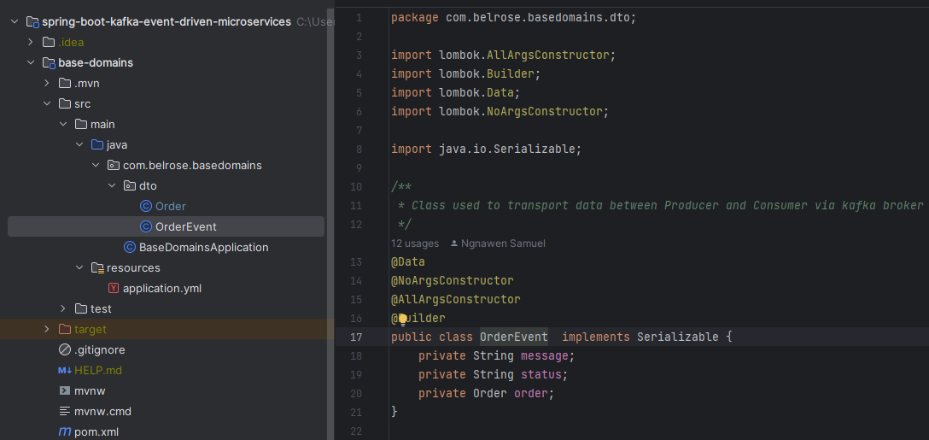

##### orderService

###### Add baseDomains as dependency in pom.xml

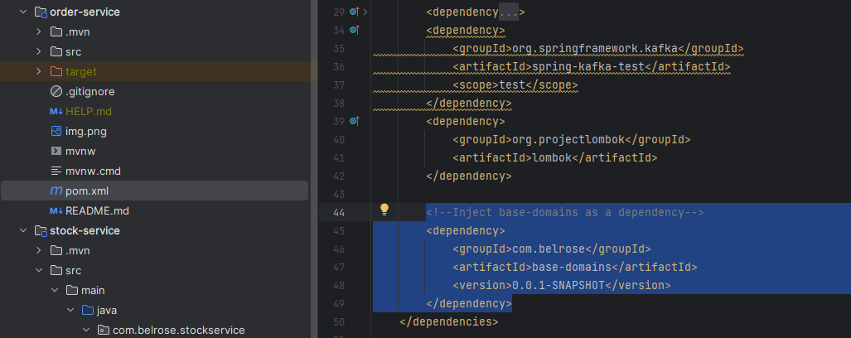

###### Create a kafka topic (KafkaTopicConfig)

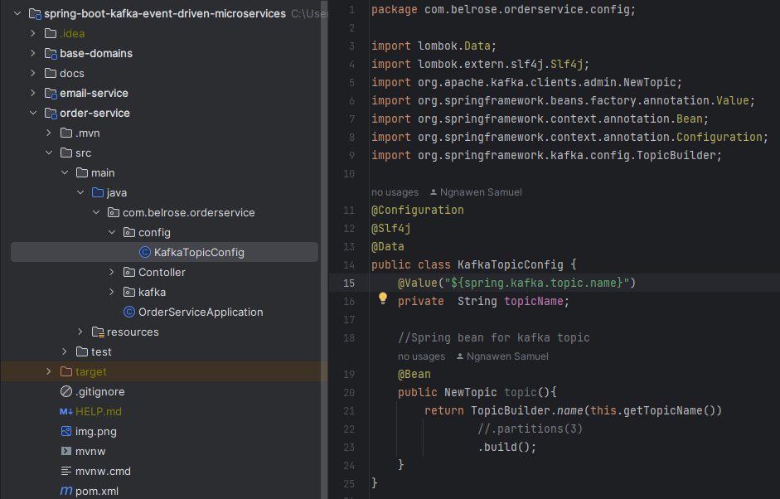

###### Create Kafka producer (OrderProducer)

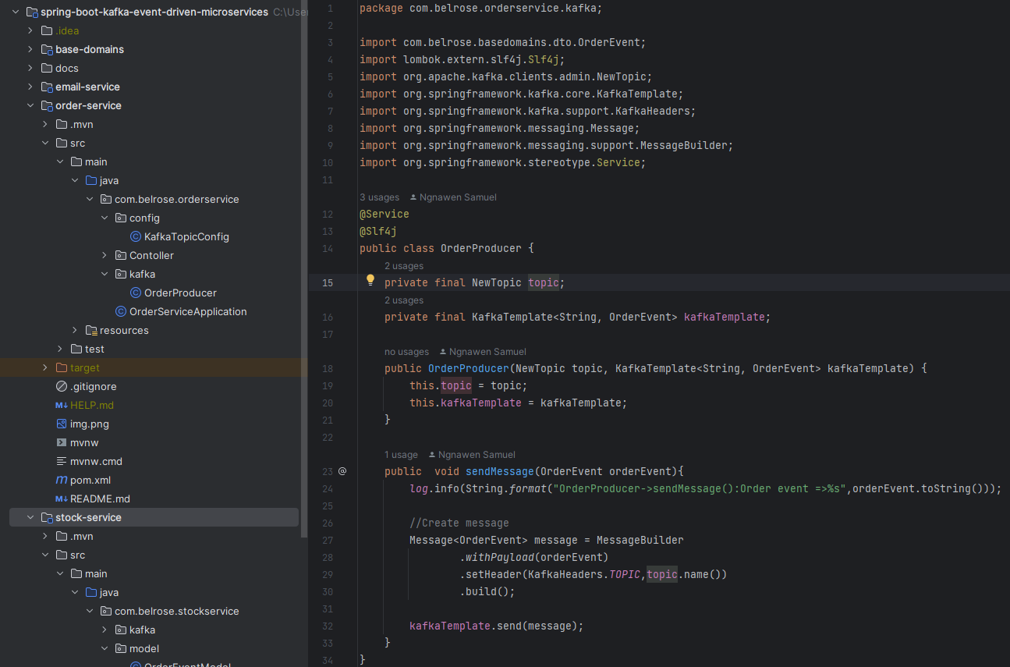

###### Create Controller

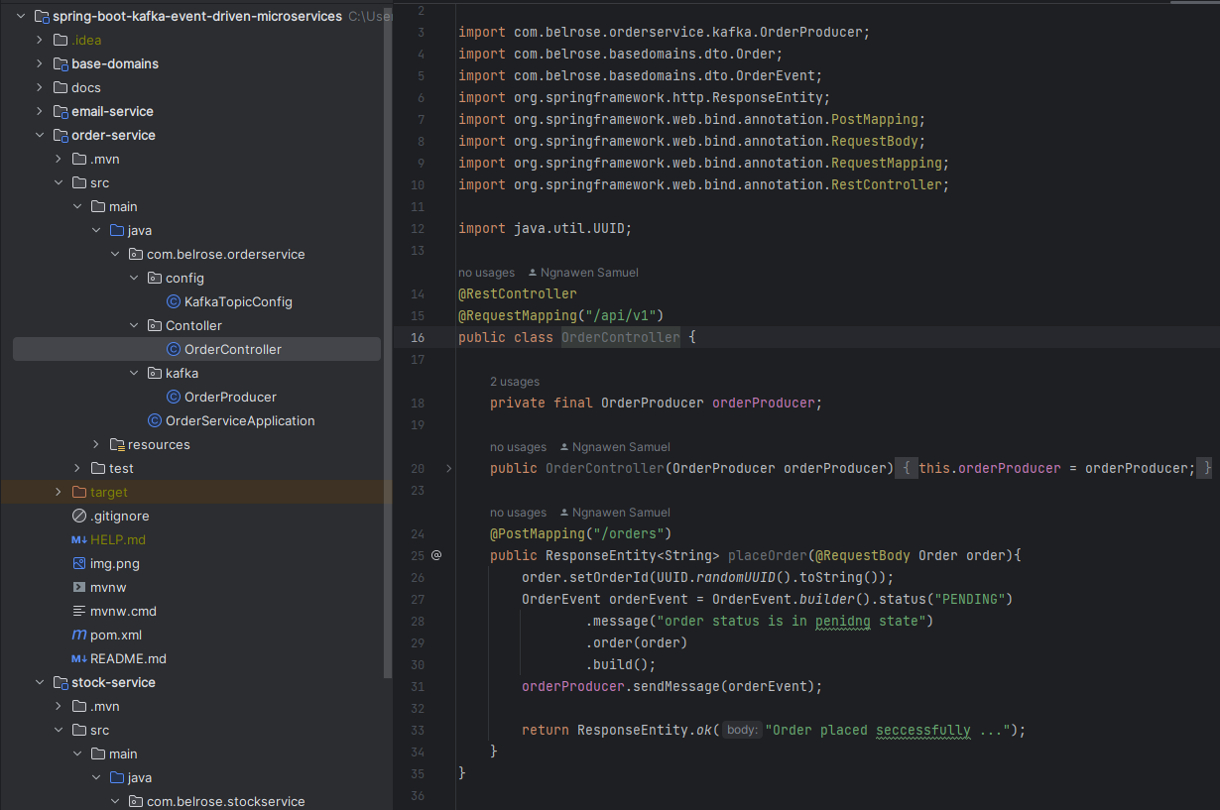

###### Run zookeeper-server and kafka-server

Here are the commands:

* .\bin\windows\zookeeper-server-start.bat .\config\zookeeper.properties
* .\bin\windows\kafka-server-start.bat .\config\server.properties

Or

* You can use the point 5) to start zookerper-server and kafka-server as the docker container

Or

* You can use the point 6) to start zookerper-server , kafka-server and kafdrop as the docker container

###### Run your spring boot project

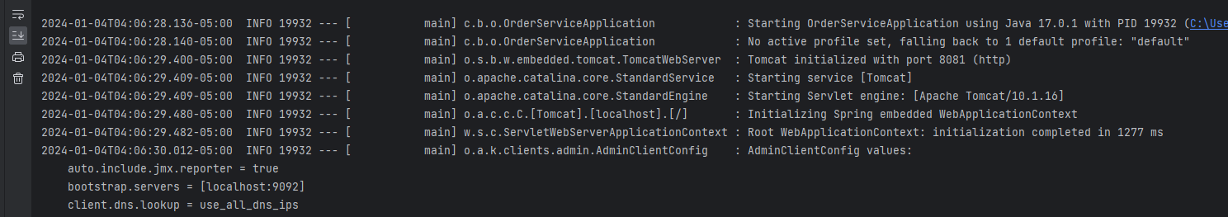

###### Send the order/message from postman/HTTPie

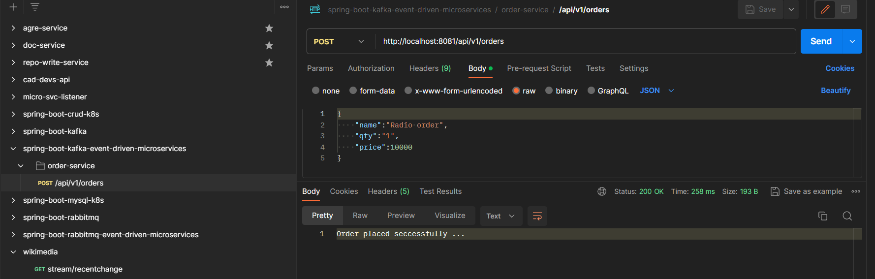

##### stockService

###### Add baseDomains as dependency in pom.xml

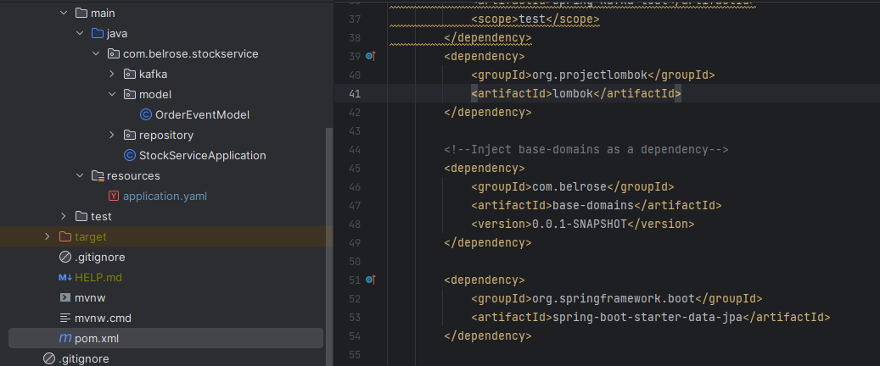

###### Create Kafka consumer (OrderConsumer)

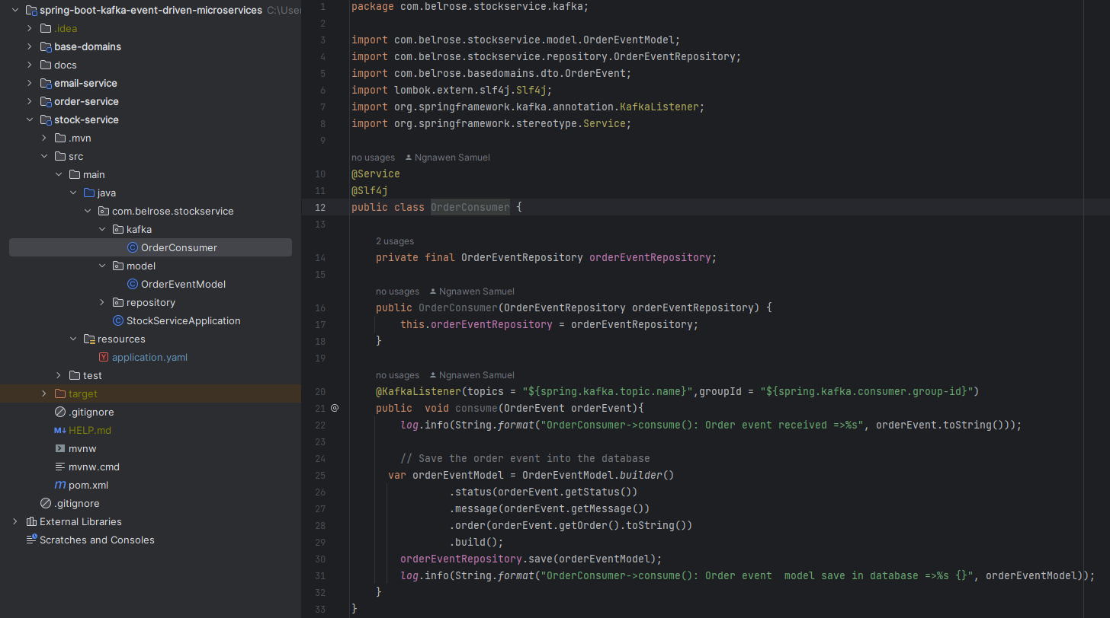

###### Run your spring boot project

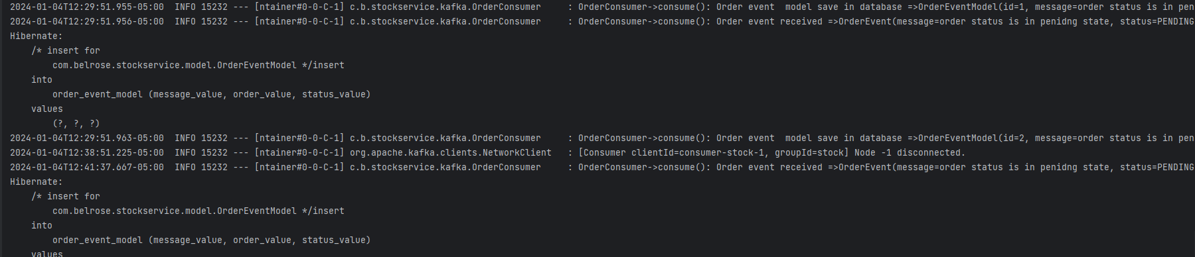

##### emailService

###### Add baseDomains as dependency in pom.xml

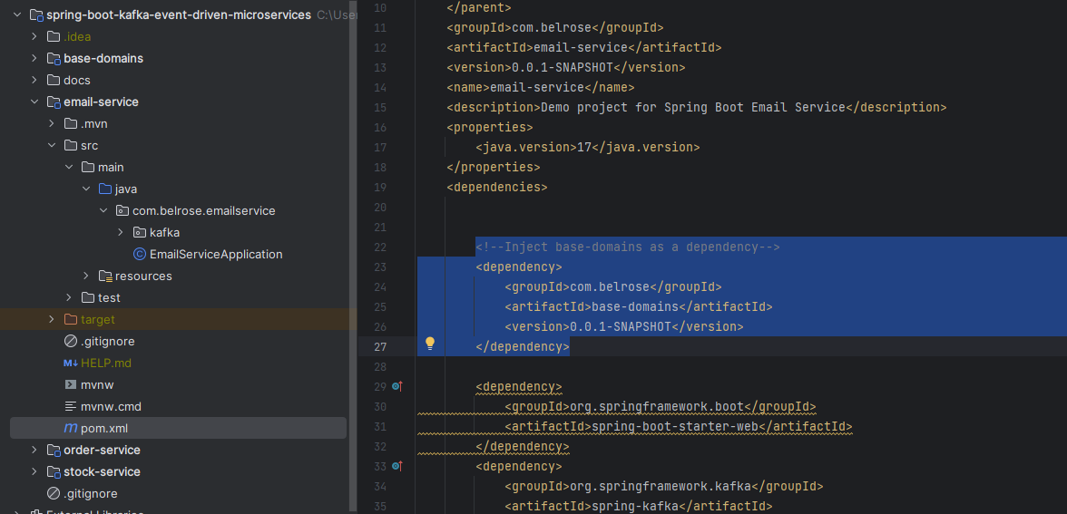

###### Create Kafka consumer (OrderConsumer)



###### Run your spring boot project

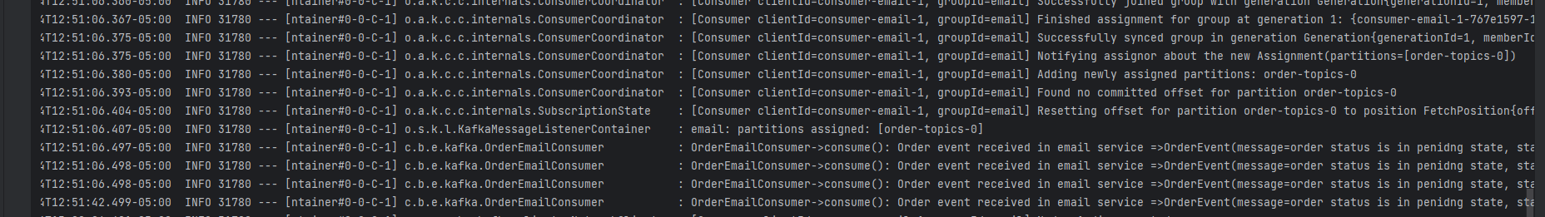

### Take a look your kafdrop

Open localhost:9000

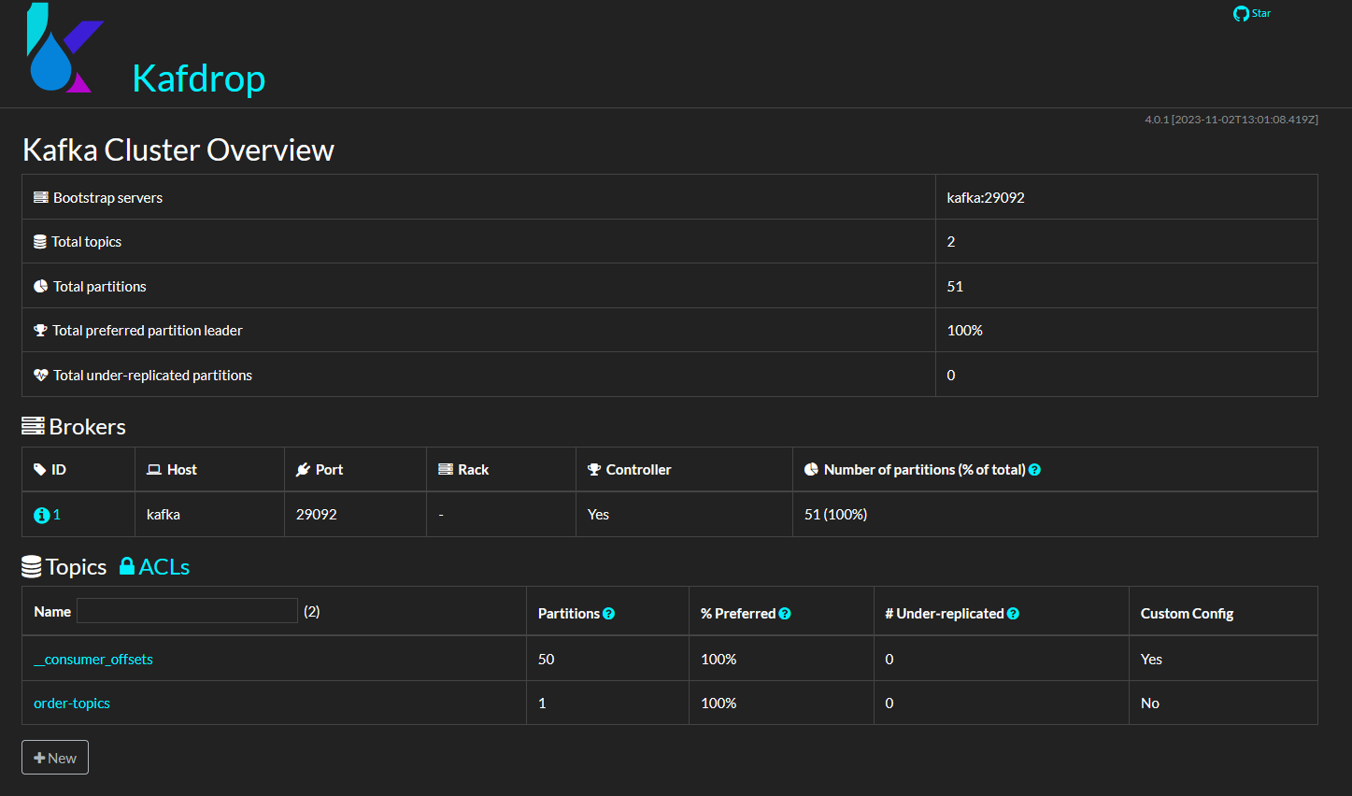

## Install and start Apache Kafka (zookeeper-server and kafka-server) Using Docker  via docker-compose yaml file

1. Create a folder
2. Create a docker compose yml file and add this

version: '3'

services:

zookeeper:

image: wurstmeister/zookeeper

container_name: zookeeper

ports:

- "2181:2181"

kafka:

image: wurstmeister/kafka

container_name: kafka

ports:

- "9092:9092"

environment:

KAFKA_ADVERTISED_HOST_NAME: localhost

KAFKA_ZOOKEEPER_CONNECT: zookeeper:2181

1. Run your docker compose yml file using this command

docker-compose -f docker-compose.yml up -d

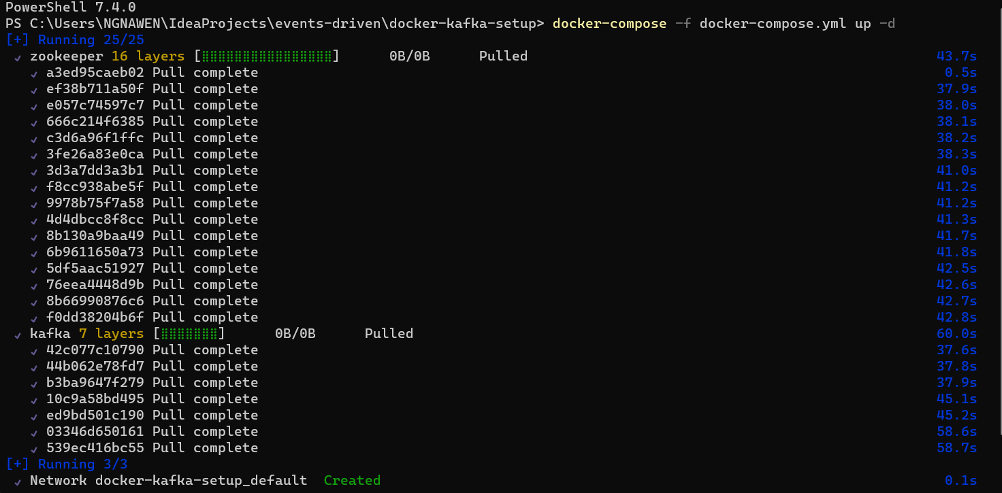

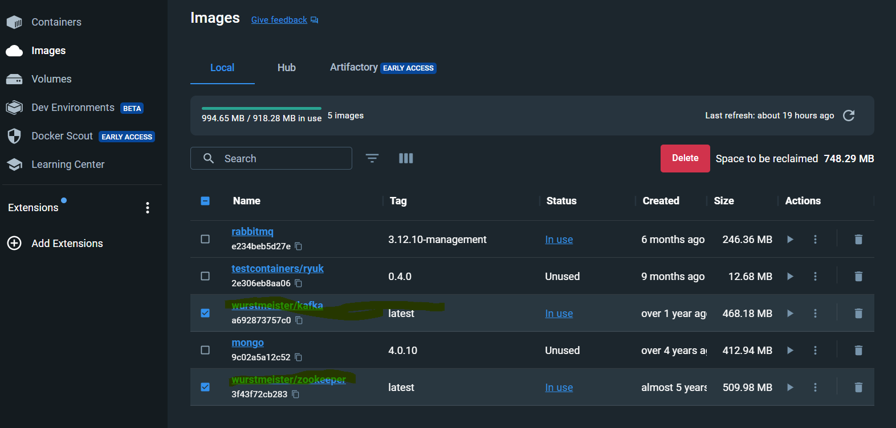

Resources: <https://betterdatascience.com/how-to-install-apache-kafka-using-docker-the-easy-way/>

## Install and start zookeeper-server, kafka-server and kafdrop Using Docker  via docker-compose yaml file

1. Create a folder
2. Create a docker compose yml file and add this

version: '3'

services:

# Zookeeper, single node

  zookeeper:

    image: wurstmeister/zookeeper:latest

    environment:

      ZOOKEEPER_CLIENT_PORT: 2181

      ZOOKEEPER_TICK_TIME: 2000

    ports:

      - 2181:2181

      - 2888:2888

      - 3888:3888

 # kafka single node

  kafka1:

    image: wurstmeister/kafka:latest

    restart: "no"

    links:

      - zookeeper

    ports:

      - 9092:9092

    environment:

      KAFKA_BROKER_ID: 1

      KAFKA_ZOOKEEPER_CONNECT: zookeeper:2181

      KAFKA_LISTENERS: INTERNAL://:29092,EXTERNAL://:9092

      KAFKA_ADVERTISED_LISTENERS: INTERNAL://kafka1:29092,EXTERNAL://localhost:9092

      KAFKA_LISTENER_SECURITY_PROTOCOL_MAP: INTERNAL:PLAINTEXT,EXTERNAL:PLAINTEXT

      KAFKA_INTER_BROKER_LISTENER_NAME: INTERNAL

      #https://github.com/wurstmeister/kafka-docker/issues/553

  kafka2:

    image: wurstmeister/kafka:latest

    restart: "no"

    links:

      - zookeeper

    ports:

      - 9093:9093

    environment:

      KAFKA_BROKER_ID: 2

      KAFKA_ZOOKEEPER_CONNECT: zookeeper:2181

      KAFKA_LISTENERS: INTERNAL://:29093,EXTERNAL://:9093

      KAFKA_ADVERTISED_LISTENERS: INTERNAL://kafka2:29093,EXTERNAL://localhost:9093

      KAFKA_LISTENER_SECURITY_PROTOCOL_MAP: INTERNAL:PLAINTEXT,EXTERNAL:PLAINTEXT

      KAFKA_INTER_BROKER_LISTENER_NAME: INTERNAL

#kafdrop for topic/msg visualization

  kafdrop:

    image: obsidiandynamics/kafdrop

    restart: "no"

    environment:

      KAFKA_BROKERCONNECT: "kafka1:29092,kafka2:29093"

      JVM_OPTS: "-Xms16M -Xmx512M -Xss180K -XX:-TieredCompilation -XX:+UseStringDeduplication -noverify"

    ports:

      - 9000:9000

    depends_on:

      - kafka1

      - kafka2

1. Run your docker compose yml file using this command

docker-compose -f docker-compose.yml up -d

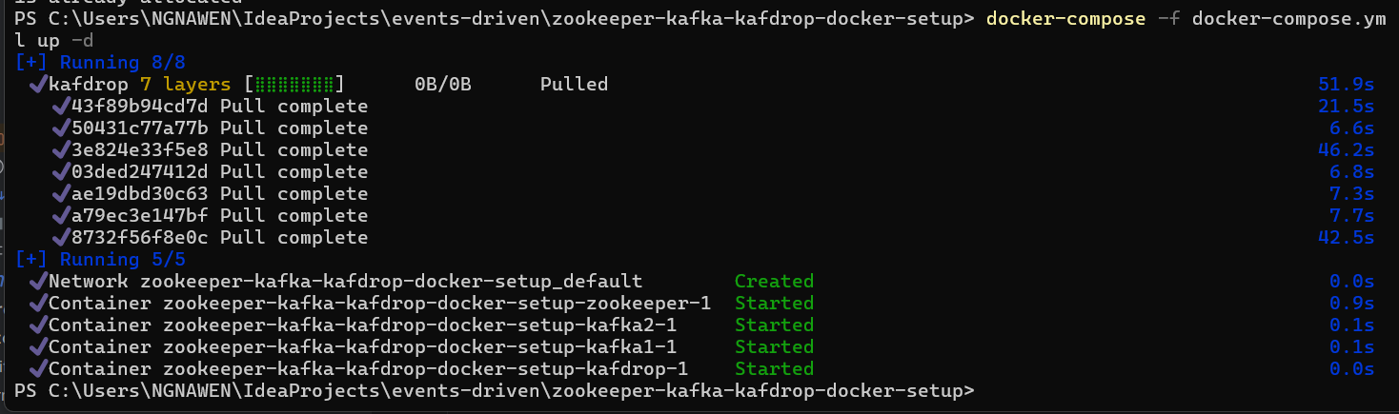

Resources:

* <https://medium.com/@cloud_geek/run-kafka-cluster-zookeeper-using-docker-kafdrop-docker-compose-52309c9f9e51>
* <https://github.com/obsidiandynamics/kafdrop>

## Apache Kafka vs RabbitMQ: Make you choose

